Name
Designation
Organisation
Address
City
State
Country
Pin Code
Telephone No.
Mobile No.
Email
Website
Facebook Page of the Organisation
Linkedin Page of the Organisation
Twitter Handle of the Organisation
Instagram Account of the Organisation

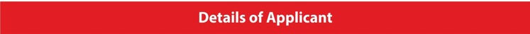

Nomination Category
Payment Mode
Payment Details (Reference Number)
Amount | INR 30,000+ 18% GST (for Each Category)
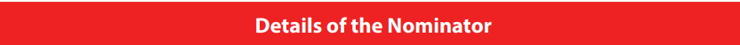
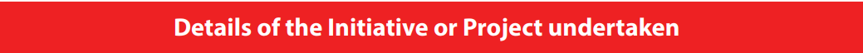

Brief Description of the project
What was the objective?
Who were the intended recipients?
Mention five novelty factors of this project
Mention five key achievements of the project

